1. **Motherboard**

The motherboard contains the microcontroller and peripherals required to test the basic I/O operations (e.g. Digital I/O, ADC, Interrupts) of it. It is a standalone board which can further connect to the other expansion boards. It contains a power section to power up the Microcontroller as well as other peripherals. In the subsequent subsections a brief description of the motherboard has been added.

* 1. Power:

The motherboard can be powered using a DC adapter of 7V-25V. The inner probe of the female DC jack in the motherboard has been set as VCC and the outer probe of the female DC jack in the motherboard is GND. There is a green LED indicating the power on. There is also a pin at the end named “12V” which is also connected to the input of voltage regulator. L7805CV has been used as the voltage regulator which can supply maximum 1A. In ideal case, when everything is detached from the motherboard, only the motherboard draws around 14mA. There are in total 7 pins of GND which are short internally. All the VCC pins draw current from the output of voltage regulator.

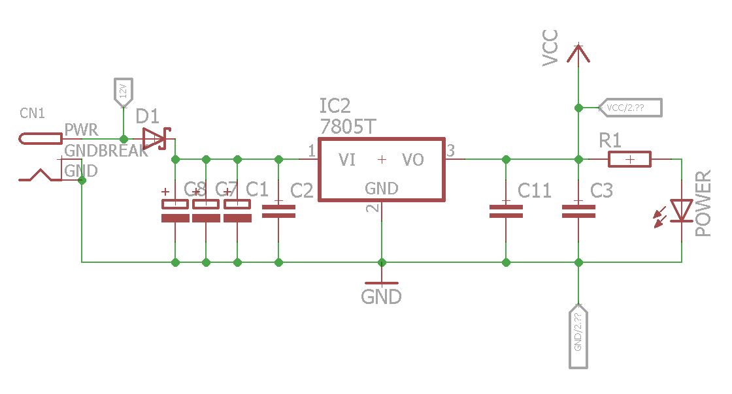

Figure : Schematic of Power Circuit of the Motherboard

* 1. LEDs:

There are 8 LEDs which are connected to the Pins of the PortD of PIC Microcontroller through a resistor network (RN1). There is a DIP switch between resistor network and VCC (SW3). 1 of SW3 does nothing. 2 of SW3 connects the resistor network with VCC when it is in ON position. So logic to turn on the LEDs is active low. The same pins have been used to control seven segments in display module. The pin mapping is presented in Table 1 .

Table : Pin Mapping of LED

|  |  |
| --- | --- |
| **LED No** | **Pin** |
| 1 | RD0 |
| 2 | RD1 |
| 3 | RD2 |
| 4 | RD3 |
| 5 | RD4 |
| 6 | RD5 |
| 7 | RD6 |
| 8 | RD7 |

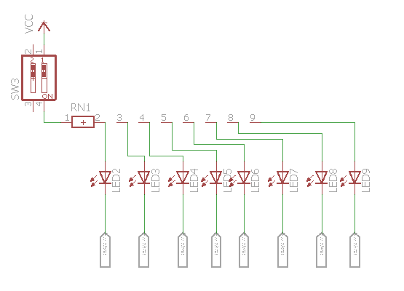

Figure : Schematic of LEDs

* 1. Buzzer:

There is an onboard buzzer which is connected through a BJT to switch. Through a jumper, the base of the BJT can be either connected with RC2 of PIC or grounded to turn off the buzzer. RC2 Pin has not been used anywhere else in other modules.

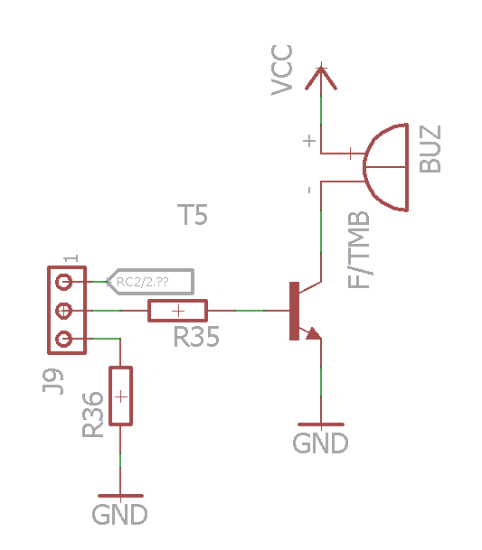

Figure : Buzzer

* 1. ADC:

There are two potentiometers of value 10K-ohm in the board. To connect them with the PIC one must short the respective pins of J2 and J3 with jumper. ADC value can be read from PIC pin RA1 and RA2. These pins also work to select seven segment displays in display module and hence if both the jumper of ADC in the motherboard and the display module is connected, the seven segment display may not work properly.

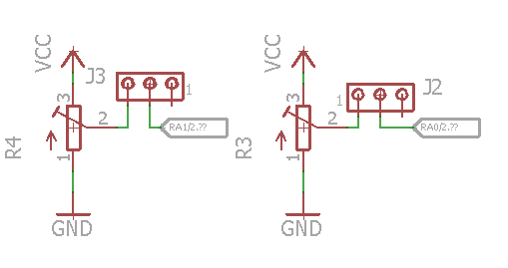

Figure : ADC

* 1. Interrupt/Digital Input:

To work with external interrupt and Digital Input, there are two push switches. Both of them are pulled down with a 10K-ohm resistance. They are by default disabled. To enable them, one needs to connect 5V and COM of J1 using jumper. The other pin of J1 has no connection. The pin out is in Table 2 and schematic in Figure 5

Table : Digital Input Pin Out

|  |  |
| --- | --- |
| **Switch** | **Pin** |
| S1 | RB0 |
| S2 | RB1 |

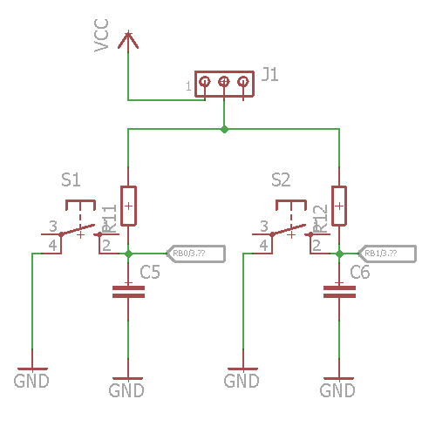

Figure : Push Button for Interrupt/Digital Input

* 1. PIC Microcontroller:

DIP version of PIC18F4550 of Microchip has been used as the Microcontroller. It is a 40 pin Microcontroller. An external 20KHz oscillator has been used. Reset pin has been pulled high with a 10k-ohm resistance. A Reset push button has been added to reset the microcontroller.

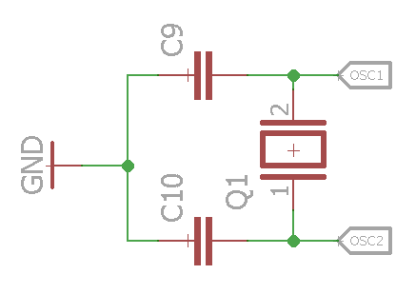

Figure : Oscillator

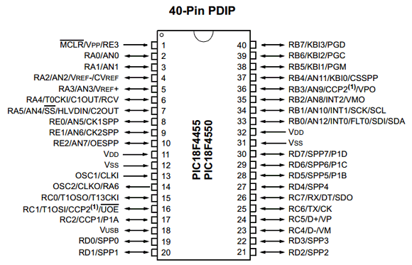

Figure : Pin out for PIC18F4550

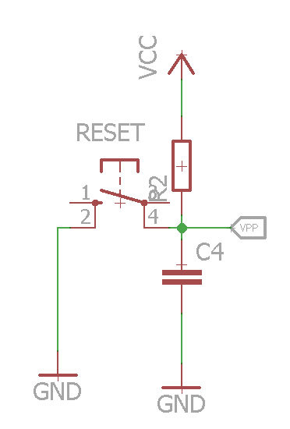

Figure : Reset

The physical condition of the mother board has been shown in Figure 9.

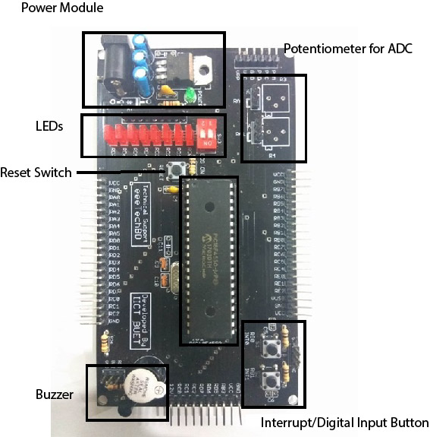

Figure : Physical Condition of Board

Pin mapping of mother Board has been presented in Table 2.

Table : Pin Mapping of Motherboard

|  |  |
| --- | --- |
| **Description** | **Pin** |
| LED0 | RD0 |
| LED1 | RD1 |
| LED2 | RD2 |
| LED3 | RD3 |
| LED4 | RD4 |
| LED5 | RD5 |
| LED6 | RD6 |
| LED7 | RD7 |
| Buzzer | RC2 |
| R3 | RA0 |
| R4 | RA1 |
| S1 | RB0 |
| S2 | RB1 |

1. **Display Module**

Display module connects with the motherboard at the side where the power module is located as shown in Figure 10. Please note that Display module cannot work alone.

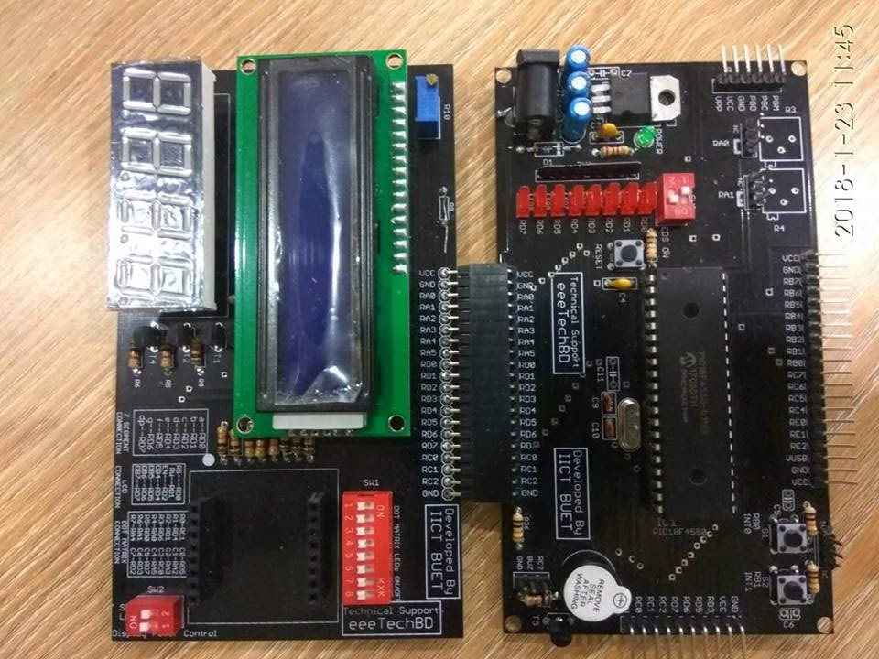

Figure : Display module Connected with Motherboard

Display module contains the following peripherals:

1. LCD Module
2. Seven Segment Display
3. Dot Matrix

A brief description of the peripherals has been presented in the subsequent subsection.

* 1. LCD Module:

LCD module of interfacing IC **HD44780** can be mounted with the display module. The pinout can be found in Table 3.

Table : LCD Pinout

|  |  |
| --- | --- |
| **LCD Pin** | **PIC Pin** |
| RS | RD0 |
| RW | RD1 |
| EN | RD2 |
| DB4 | RD4 |
| DB5 | RD5 |
| DB6 | RB6 |
| DB7 | RD7 |

The brightness of the LCD can be controlled using the R10 potentiometer. The power of the LCD can be controlled using 1st switch of SW2. The full circuit is shown in Figure 11.

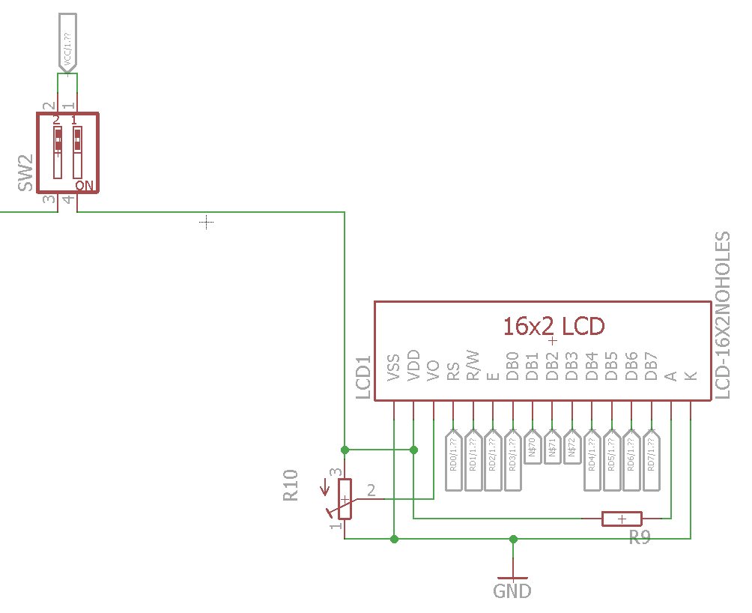

Figure : Circuit of LCD

* 1. Seven Segment:

The board can equip a 4 digit seven segment module. The seven segment module must be common anode type i.e. the positive pins are connected together as common. The power can be controlled using 2nd switch of SW2. To switch from one seven segment to another, BJT has been used. The pinout and schematic can be found in Table 4 and Figure 12 respectively.

Table : Pin out of Seven Segment Display

|  |  |
| --- | --- |
| **Description** | **Pin** |
| 1st Digit | RA2 |
| 2nd Digit | RA1 |
| 3rd Digit | RA0 |
| 4th Digit | RA3 |
| a pin of Seven Segment | RD0 |
| b pin of Seven Segment | RD1 |
| c pin of Seven Segment | RD2 |
| d pin of Seven Segment | RD3 |
| e pin of Seven Segment | RD4 |
| f pin of Seven Segment | RD5 |
| g pin of Seven Segment | RD6 |
| cp pin of Seven Segment | RD7 |

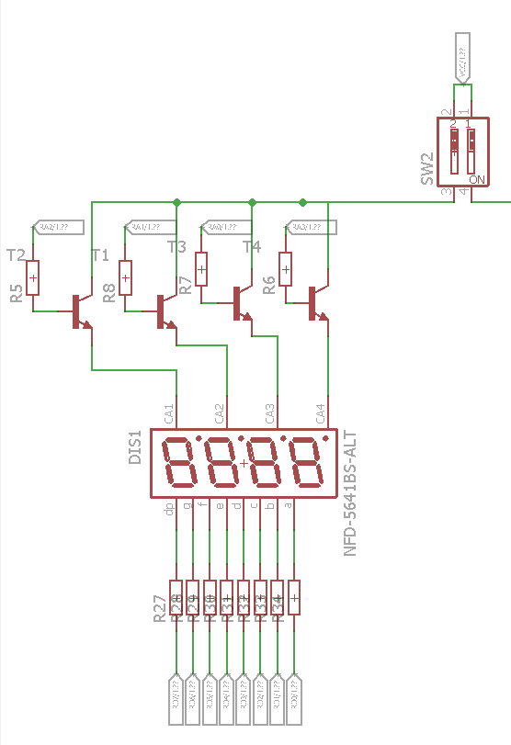

Figure : Schematic of Seven Segment Display

* 1. Dot Matrix

A 8x8 dot matrix can be mounted with the display module. The schematic of the Dot Matrix and pinout of it can be found at Figure 13 and Table 5 respectively.

Table : Pin Description of Dot Matrix

|  |  |
| --- | --- |
| **Description** | **Pin of PIC** |
| Column 1 | RD5 |
| Column 2 | RA2 |
| Column 3 | RA3 |
| Column 4 | RC0 |
| Column 5 | RA5 |
| Column 6 | RD7 |
| Column 7 | RD3 |
| Column 8 | RD2 |
| Row 1 | RC1 |
| Row 2 | RD4 |
| Row 3 | RD1 |
| Row 4 | RD6 |
| Row 5 | RA0 |
| Row 6 | RD0 |
| Row 7 | RA1 |
| Row 8 | RA4 |

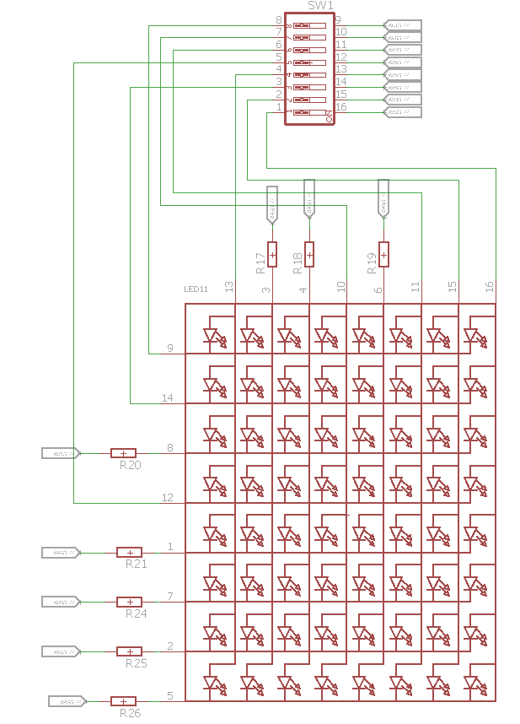

Figure Schematic of Dot Matrix

1. **Expansion Board**

Display module connects with the motherboard at the side where the interrupt switch is located as shown in Figure 14. It contains RTC, Keypad and some pins for other communication protocols like Serial, USB, SPI and I2C.

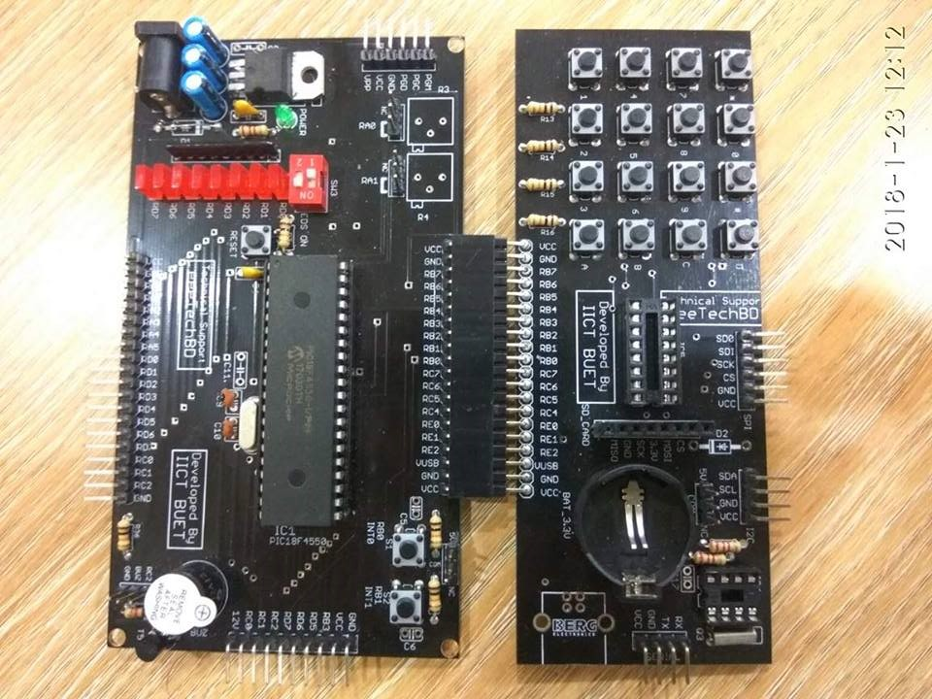

Figure : Expansion Board with Motherboard

* 1. RTC:

RTC was implemented with a famous chip DS1307. There is a holder for connecting an external Lithium coin cell battery of 3.3V. It keeps the RTC IC alive if the VCC is shut off. There is a 36.768KHz Crystal attached with the IC. DS1307 communicates with PIC in I2C protocol. The SDA and SCL line has been pulled up using 10K-ohm resistance. But, they are not connected until one connects the jumper (J7) beside the battery and shorts com and 5V pins. The schematic has been shown in Figure 15.

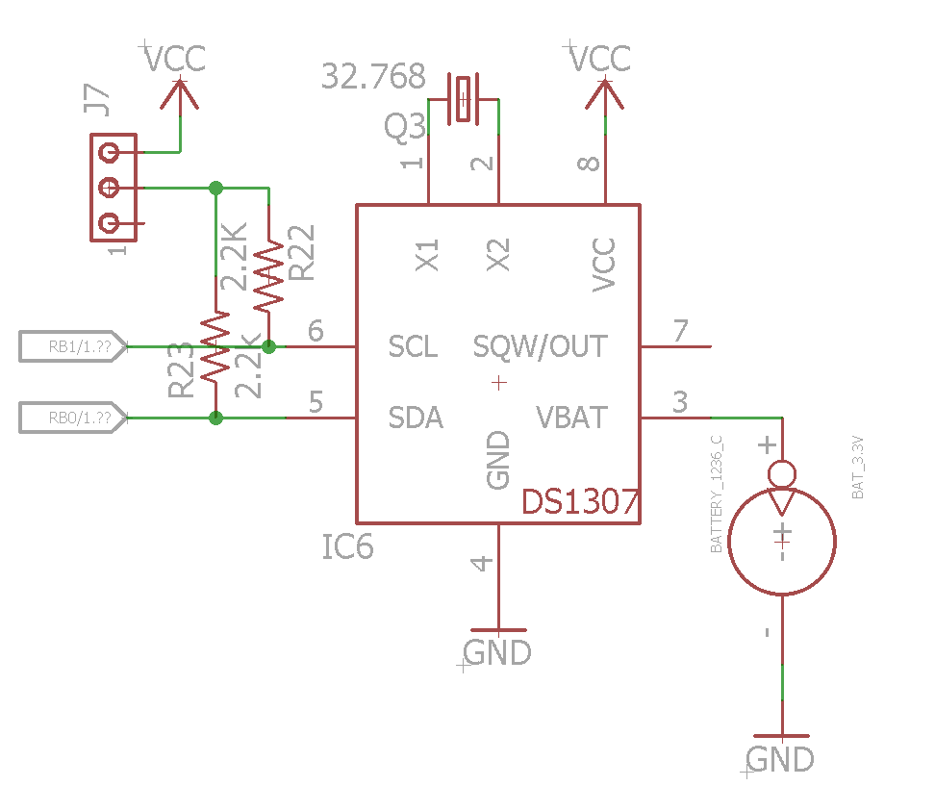

Figure : Schematic of RTC

* 1. Keypad

There is a 4X4 keypad in the expansion board. The column lines are pulled up using 10K-ohm resistances. The pinout and schematic can be found at Table 6 and Figure 16 respectively.

Table : Pin Out for Keypad

|  |  |
| --- | --- |
| **Description** | **Pin** |
| Column 1 | RB7 |
| Column 2 | RB6 |
| Column 3 | RB5 |
| Column 4 | RB4 |
| Row 1 | RB3 |
| Row 2 | RB2 |
| Row 3 | RB1 |
| Row 4 | RB0 |

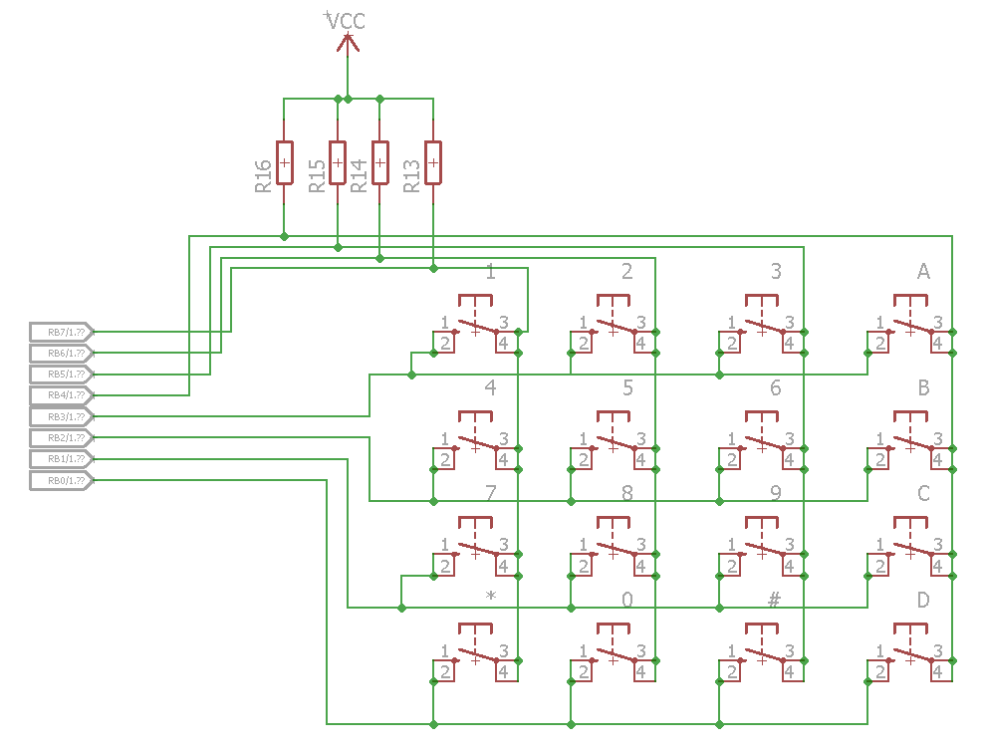

Figure : Keypad Schematic

* 1. SD Card:

There is an SD card pin out in the expansion board. SD card communicates with PIC using SPI protocol and the logic level is 3.3V. A CMOS inverting Converter, CD4050 has been used to convert the 5V logic to 3.3V logic. The pin diagram has been presented in Table 7 and the schematic has been shown in Figure 17.

Table : Pin Description of SPI Protocol

|  |  |
| --- | --- |
| **Description** | **Pin** |
| CS | RB2 |
| MOSI | RC7 |
| SCK | RB1 |
| MISO | RB0 |

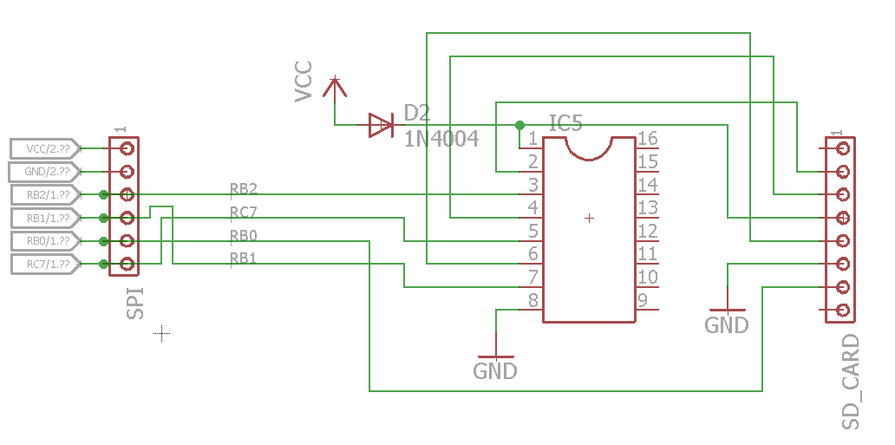

Figure : The Schematic of SD Card

1. **Total Pin Mapping of PIC**

|  |  |  |  |
| --- | --- | --- | --- |
| Name | Display Module | Mother Board | Expansion Board |
| MCLR/VPP/RE3 |  |  |  |
| RA0/AN0 | 7Segment_selection_3/ DotMatrix_row_5 |  |  |
| RA1/AN1 | 7Segment_selection_2/ DotMatrix_row_7 | Potentiometer 1 |  |
| RA2/AN2/VREF-/CVREF | 7Segment_selection_1/ DotMatrix_col_2 | Potentiometer 2 |  |
| RA3/AN3/VREF+ | 7Segment_selection_4/ DotMatrix_col_3 |  |  |
| RA4/T0CK1/C1OUT/RCV | DotMatrix_row_8 |  |  |
| RA5/AN4/SS/HLVDIN/C2OUT | DotMatrix_col_5 |  |  |
| RE0/AN5/CK1SPP |  |  |  |
| RE1/AN6/CK2SPP |  |  |  |
| RE2/AN7/OESPP |  |  |  |
| VDD |  |  |  |
| Vss |  |  |  |
| OSC1/CLK1 |  |  |  |
| OSC2/CLKO/RA6 |  |  |  |
| RC0/T1OSO/T13CK1 | DotMatrix_col_4 |  |  |
| RC1/T1OSI/CCP2/UOE | DotMatrix_row_1 |  |  |
| RC2/CCP1/P1A |  | Buzzer |  |
| VUSB |  |  |  |
| RD0/SPP0 | LCD_RS/ 7Segment_a/ DotMatrix_row_6 | LED0 |  |
| RD1/SPP1 | LCD_RW/ 7Segment_b/ DotMatrix_row_3 | LED1 |  |
| RD2/SPP2 | LCD_En/ 7Segment_c/ DotMatrix_col_8 | LED2 |  |
| RD3/SPP3 | 7Segment_d/ DotMatrix_col_7 | LED3 |  |
| RC3/D-/VM |  |  |  |
| RC4/D+/VP |  |  |  |
| RC6/TX/CK |  |  |  |
| RC7/RX/DT/SDO |  |  | SD_MOSI |
| RD4/SPP4 | LCD_DB4/7Segment_e/ DotMatrix_row_2 | LED4 |  |
| RD5/SPP5/P1B | LCD_D5/7Segment_f/ DotMatrix_col_1 | LED5 |  |
| RD6/SPP6/P1C | LCD_D6/7Segment_g/ DotMatrix_row_4 | LED6 |  |
| RD7/SPP7/P1D | LCD_D7/7Segment_cp/ DotMatrix_col_6 | LED7 |  |
| Vss |  |  |  |
| VDD |  |  |  |
| RB0/AN12/INT0/FLT0/SDA |  | S1 | RTC_SDA/Keypad_Row_4/SD_MISO |
| RB1/AN10/INT1/SCK/SCL |  | S2 | RTC_SCL/ Keypad_Row_3/ SD_SCK |
| RB2/AN8/INT2/VMO |  |  | Keypad_Row_2/ SD_CS |
| RB3/AN9/CCP2/VPO |  |  | Keypad_Row_1 |
| RB4/AN11/KBI0/CSSPP |  |  | Keypad_Col_4 |
| RB5/KBI1/PGM |  |  | Keypad_Col_3 |
| RB6/KBI2/PGC |  |  | Keypad_Col_2 |
| RB7/KBI3/PGD |  |  | Keypad_Col_1 |